Name ________________________________________ Date ________________________
Pre- Algebra- Q4 Quiz # 1 Review

- Which ordered pair satisfies the system of equations? 3x – y = 8
x + y = 2

a. (3,-1) b. (2.5, 0.5) c. (2.5, -0.5) d. (5, -3)

- Solve for b: a + 3b = 15
a + b = 5

a. 1 b. 5 c. 7 d. 4

- How many solutions does each of these systems have? {zero, one or infinite}

y = 3x + 7 y = 2(x + 8) y = 0.5x + 2
y = 2x + 3 y = 2x + 16 y = $\frac{1}{2}$x - 9

_____________________ _______________________ _________________________

- What do parallel lines have in common?

_________________________________________________________________

Write the equation of a line that is parallel to y = 4x – 8

_______________________________________________

5. Solve and check algebraically: y = 2x
3x + 2y = 21

6. Solve and check algebraically: 4x + 3y = 27
y = 2x – 1

7. Solve and check algebraically: 2x – 9y = 17
5x + 9y = 11

8. Solve and check algebraically: 4x – 3y = 1
2x + y = 3

9. Solve graphically: 10. Solve graphically:

y = - $\frac{1}{2}$x + 6 2x + y = 8
y = 2x + 1 y – x = 2

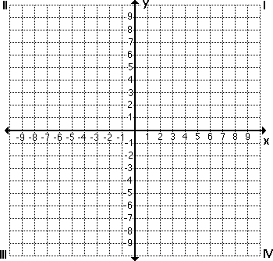

11. Write and solve a system of equations:

You buy 8 hostas and 15 geraniums for $193. Your friend buys 3 hostas and 12 geraniums for $117. Find the cost of each hosta and each geranium.

Let statements: Equations:

cost of one hosta _______________ cost of one geranium __________________

12. Sandra and her friends visit the concession stand at a baseball game. The stand charges $2 for a hot dog and $1 for a drink. They spend a total of $11 on 8 items. Write and solve a system of equations to determine how many hot dogs and how many drinks were bought?

Let statements: Equations:

# of hot dogs ____________________ # of drinks ______________________

