Name ____________________________________ Period _____

Pre- Algebra- Quarter 4 Review Sheet

1. 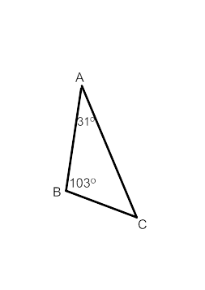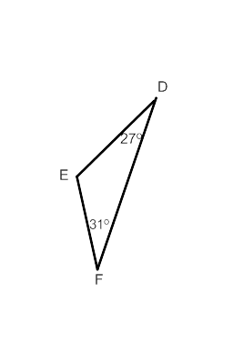Which statement is true?

A. 

B. 

C. 

D. 

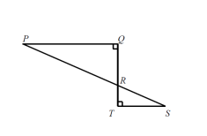2. In the figure shown, PQ = 12 centimeters, ST = 6 centimeters and *m*<QRP= 72.

Find *m*<S.

1) 720 2) 360

3) 1080 4) 180

3. If a figure is dilated from center O by a scale factor r= ½, would the scale factor push or pull away the image from the center?

4. Find the image of (5,10) for a dilation centered at the origin with a scale factor .

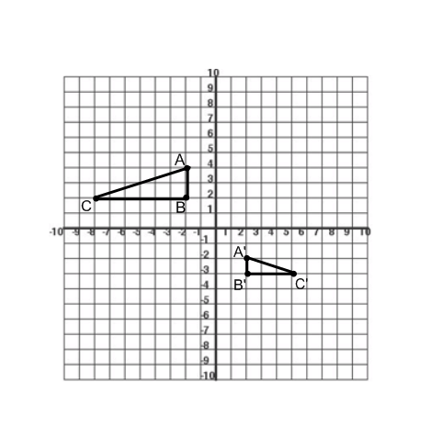

5. What sequence of transformations maps ΔABC onto ΔA’B’C’?

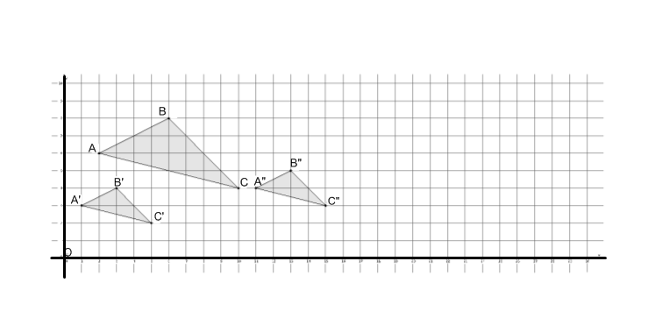

6. In the picture below we have a triangle $ABC$, that has been dilated from center $O$, by a scale factor of $r=\frac{1}{2}$. It is noted by $A'B'C'$. We also have triangle $A''B''C'',$ which is congruent to triangle $A'B'C'$ (i.e., $∆A'B'C'≅∆A''B''C''$).

Describe the sequence that would map triangle $A''B''C''$ onto triangle $ABC.$

First Step: Find scale factor.

Second Step: Find rigid motion.

Third Step: Use precise language to describe the sequence.

7. A line crosses the y-axis at (0, -2) and rises 3 units up for every 2 units is moves left.

Which one represents the equation of the line? (choose one)

a) y = 3x + 2

b) y = x – 2

c) y = x + 2

d) y = -2x – 2

8. Which ordered pair satisfies the system of equations below?

3x – y = 8

x + y = 2

(A) (3, -1) (B) (2.5, 0.5) (C) (2.5, -0.5) (D) (5, -3)

9. How many solutions does a system have if the lines are parallel?

(A) 0 (B) 1 (C) 2 (D) infinite

10. Solve the following systems graphically

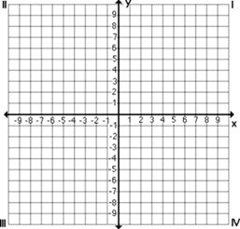

2x + y = 8 y – x = 2

Solve the systems algebraically

11. 8a + 5b = 9 12. y = -2x – 4 13. x – 2y = 16

2a – 5b = -4 -6x + 3y = -12 y = 2x + 1

14. At the Savemore Supermarket, 3 pounds of squash and 2 pounds of eggplant cost $2.85. The cost of 4 pounds of squash and 5 pounds of eggplant is $5.41. What is the cost of one pound of squash, and what is the cost of one pound of eggplant?

15. Given the figure JKLM with vertices J(0,-4) K(0,6) L(4,4) and M(4,2) graph the image J’K’L’M’ after a dilation with a scale factor of ½. Then, using J’K’L’M’ as your new preimage, translate J’K’L’M’ 5 units left and 1 unit up and label the new figure J”K”L”M”.

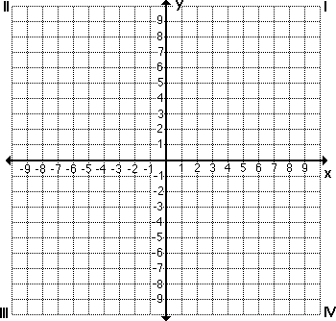

16. In the diagram of , line segment  is extended to D,  and . Find .

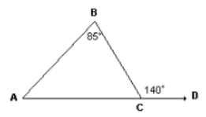

A. 150 C. 1800

B. 550 D. 2350

17. Dakota drew a triangle in the coordinate plane and applied 3 transformations.

* First, she reflected the triangle over the y-axis
* Then she rotated the resulting image 90o about the origin
* Finally, she translated the third triangle up 3 units

Which statement correctly describes the effect of this sequence of transformations on the original triangle?

1. Only the angle measures changed
2. Only the side lengths changed
3. Neither the angle measures nor side lengths changed
4. Both the angle measures and side lengths changed

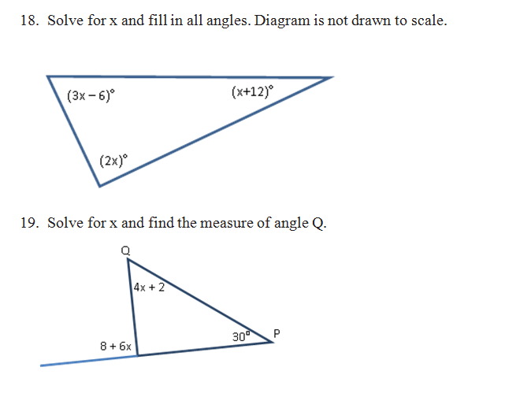

20. Line AB and CD are parallel. Line GH intersects the parallel lines at points E and F.

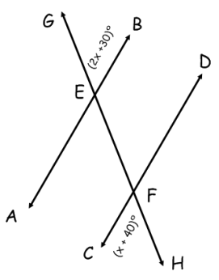

A) Geometry Fact _______________

B) Solve for x: _____________

C) Solve for : _____________

D) Solve for : _____________

21. Line AB intersects line CD at point E.

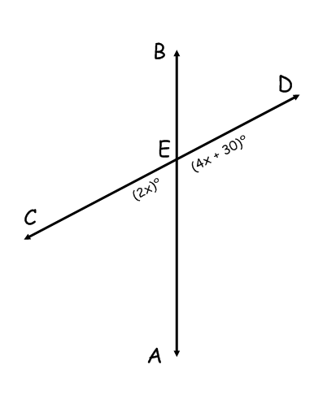A.) Geometry Fact __________________

B.) Solve for x: ______________

C.) Solve for : __________

*[not drawn to scale]*

D.) Solve for : __________

22. Use the diagram to answer the question below.

$$k||l$$

$$k$$

$$l$$

$$A$$

$$B$$

$$C$$

$$D$$

$$E$$

Line $k$ is parallel to line $l$. $m ∠ EDC=41°$ and $m ∠ ABC=32°$. Find the $m ∠ BCD$. Explain in detail how you know you are correct. Add additional lines and points as needed for your explanation.

23. In triangle $∆ABC$, point M is the point of intersection of the bisectors of angles BAC, ABC, & ACB. The measure of angle ABC is 50° and the measure of angle BAC is 70°. What is the measure of angle BMC? Show ALL work!

**A**

**M**

**B**

**C**

[not drawn to scale]