Name __________________________ Date _____________

Pre- Algebra Period ____________

Review Sheet

Use the following diagram to answer questions 1-4. In the diagram below $\overset{⃡}{JK}||\overset{⃡}{LM}$, and line n is a transversal.

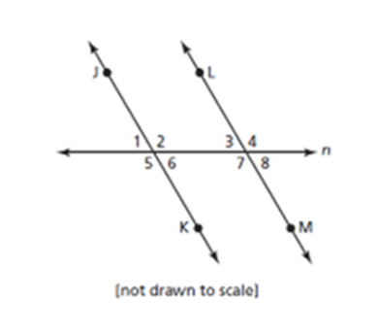

1. Name both pairs of alternate interior angles.



2. Name two pairs of corresponding angles.



3. Name two pairs of vertical angles.



4. Name two pairs of supplementary angles.



5. A triangle has angles measuring 25° and 60°. What is the measure of the triangle’s

third angle?

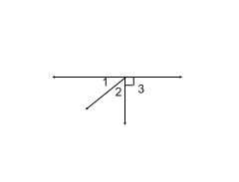6. In the figure below, m<1=x and m <2 = x-6. Which statement could be used to prove

that x = 48.

A) m<1=m<2 B) m<2=48 C) m<1+m<2=90 D) m<1 + m<2 = 180

7. Find each angle measure. What geometry fact did you use to solve this?

 

8. Find each angle measure. What geometry fact did you use to solve this?





9. Find the value of x and each angle measure.

(2x + 8) (3x – 3)°

10. In the accompanying diagram AOB is a straight line, m AOD = 6x-20 and

m < BOD = 2x. What is the value of x?

## Show your work

D

(6x-20)

# (2x)

B

A

O

11. In the accompanying diagram, ABC is a straight line and m < CBE = 35.

Find m<ABD.

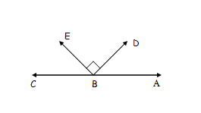

## Show your work

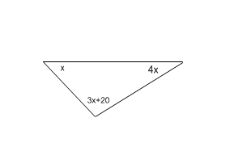12. Find each angle measure.

13. Triangle *ABC,* with side  extended to *D,* is shown in the accompanying diagram. If and , what is ?

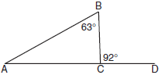

For questions 14 and 15 look at the diagram to the right.

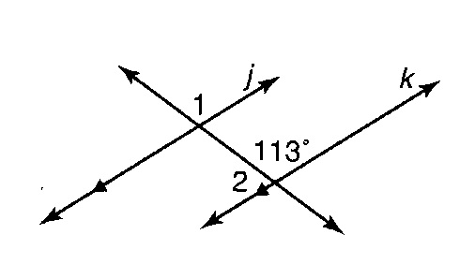14. Find m∠1.

A. 67o B. 87o C. 113o D. 24o

15. Find m∠2.

A. 67o B. 87o C. 113o D. 24o

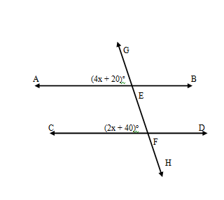16. In the accompanying diagram AB CD. If the  and the , find the value of .

17. The diagram shows a pair of intersecting lines.

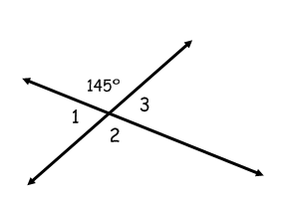

[not drawn to scale]

What is the measure of ∠1?

A) 900 B) 1450 C) 450  D) 350

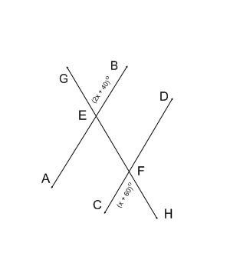18. Find the measure of <GEB.

What is the angle measure of < GEA?

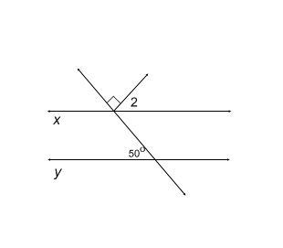

19. In the figure below, line x is parallel to line y. What is the measure of angle 2?

20. Use the diagram to answer the question below.

$$k||l$$

$$k$$

$$l$$

$$A$$

$$B$$

$$C$$

$$D$$

$$E$$